UV Disinfection Lamp

Removable With Wheels

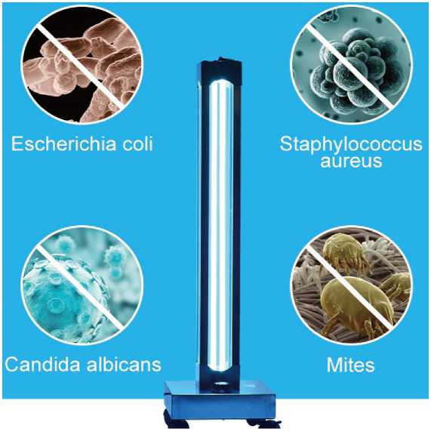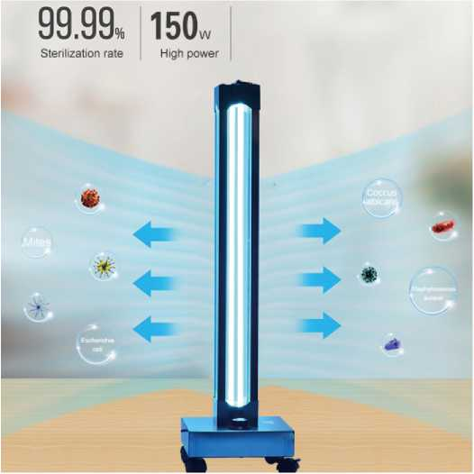



**Warning:**

**When the germicidal lamp is working, people, animals and plants must leave the scene!! Direct exposure to ultraviolet radiation may cause damage to human skin and eyes.**

Product Description

Remote Control

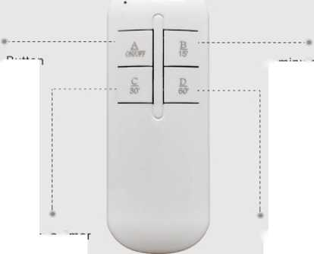

Three Time

30 minute timer

60 minute timer

15/30/60 intimate timing, when people leave their homes, People come back and sterilize

Switch Button

15 minute timer

**Product name:** UV+ Ozone disinfection lamp

**Product model:** BB-VP-150W-A1

**Power:** 150W

**Rated voltage:** 220V, 110V

**Rated frequency:** 50Hz

**Product size:** 290*290*930mm

**Control Mode:** Remote control

**Wavelength: 253.7nm**(no ozone)

/185nm(with ozone)

**Battery (for remote control):**

2*AAA batteries(Not included)

**Application area:** 20-180m2

Efficacy: Suitable for various occasions’ sterilization, air purification, deodorization and formaldehyde removal.

Product Details

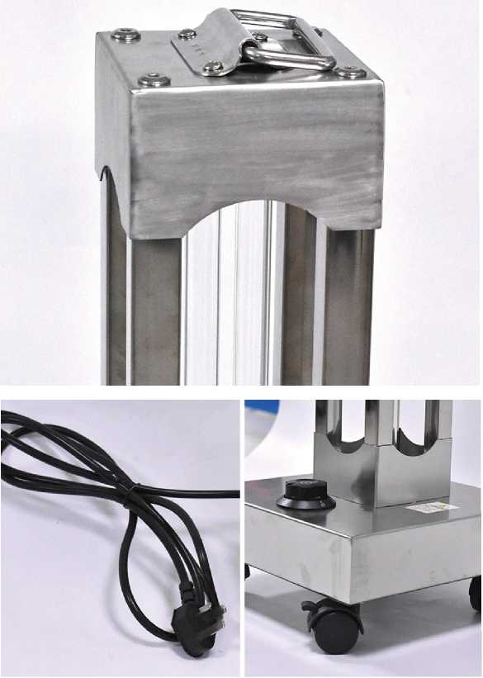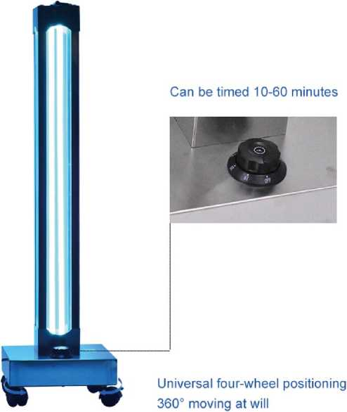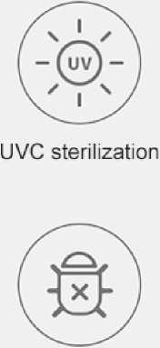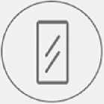

304 stainless steel

Adopt gb 10A 1.5 meter long power cord

Stainless steel base is safe and firm

The glass coating will filter out the wavelength radiation that produces ozone.

Quartz glass lamp tube

Effective except mites

Three timing Settings Remote control through the wall

Application

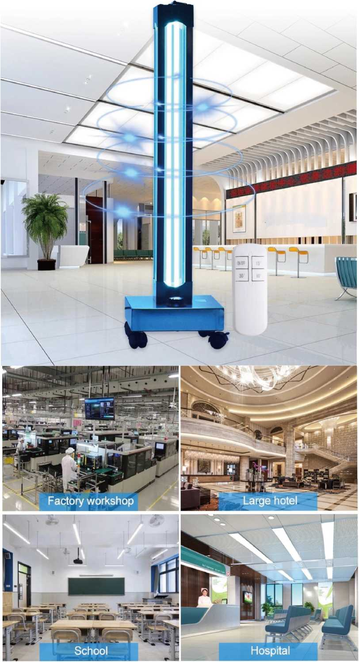

Wavelength

Special Note

Short wave UVC sterilizes ultraviolet light

Detailed analysis of short wave UVC spectral wavelength

**lOOrwn 40Qnm 760nm**

X Ray 1 Ultraviolet {uv} Visible llghl 1 infrared

Ultraviolet wavelength

Short Wave Ultraviolet I Uvb I Uva

100nm 200nm 280nm 300nm 320nm 340nm 360nm 380nm 400nm

**Sterllizini ultraviolet Erythema ultraviilet Black spat ultraviolet**

1. Do not look directly at the ultraviolet light source. It should be used in the absence of people, pets, or plants. The strong ultraviolet rays may cause skin erythema, eye and conjunctival irritation, and fatigue.
2. Prolonged exposure to ultraviolet rays can burn people's skin and eyes. Prolonged inhalation of ozone can hurt people's respiratory tract. Doors and windows must be closed during disinfection. People and animals must leave.
3. Ozone is a very unstable gas, which is usually divided into oxygen in the air for 30-40 minutes. Use ozone disinfection lamp to open the door at least 40 minutes after disinfection.



Precautions

1. **The surface of the lamp is often wiped with an alcohol cotton ball (usually every 2 weeks or so) to remove the dust and grease on the lamp: to reduce the impact on UV penetration.**
2. **Keep the room clean during ultraviolet disinfection. The ultraviolet rays cannot reach the shaded area. Please pay attention when using.**
3. **Ultraviolet rays cannot penetrate the surface of objects (such as paper, cloth, etc.). Only the side that is directly irradiated can achieve the purpose of disinfection. Therefore, it must be flipped when it is connected, so that each side can be irradiated with a certain dose. Generally 30 to 60 minutes can achieve disinfection effect.**
4. **When using ozone ultraviolet germicidal lamp, avoid leakage of ozone, so as not to cause damage to the human mucous membrane. After the germicidal lamp is finished, open the door and window for 30 minutes.**
5. **After the lamp has been ignited for a long time, there will be attenuation of the ultraviolet radiation flux. When the external radiation flux cannot reach the standard, the lamp tube needs to be replaced to avoid affecting the sterilization effect.**
6. **When replacing the lamp, you should always hold the lamp head part. Do not grasp the transparent glass tube to avoid leaving fingerprints, sweat, and dirt, which will affect the UV projection effect.**
7. **Do not use volatile oil, thinner, gasoline to wipe the body.**
8. **This product is for indoor use only. If the machine is not used continuously fora long time, please unplug the power plug.**
9. **If the power cord or external flexible cord is damaged, it must be replaced and repaired by the manufacturer or a professional.**
10. **When disinfecting indoors, please shield or isolate precious calligraphy, paintings and plants to prevent oxidation, discoloration or damage.**

Instructions

Instructions for use of ultraviolet germicidal lamp:

1 .Please leave the room within 10 seconds after opening. During use people and animals shall not stay at the site to avoid skin burns. If you need to observe the use of germicidal lamp, please do not use the naked eye to directly look at the lighted lamp tube to avoid eye swelling or burning.

2. After disinfection, please open doors and windows for ventilation and enter the room 15 minutes later.lf the sterilized lamp with ozone is used, please continue to close the door and wait for 10 minutes after use, and then open the door for ventilation for 20 minutes before entering.

3. It is recommended to protect the high grade silk, leather, paintings, precious collection and items with important commemorative significance from the light; it is not recommended to put them on the white bedspread or tablecloth for disinfection, so as to avoid fading caused by too strong ultraviolet.

1. After disinfection, please turn off the power of the sterilization lamp to prevent unnecessary injuries caused by children or pets accidentally turning on the touch switch.
2. Feature disinfection, sterilization, odor removal, f
3. Place of use: family, school, hospital, office, etc.

Package

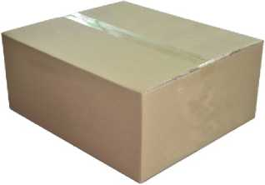

**Carton box**

|  |  |  |  |  |
| --- | --- | --- | --- | --- |
| Quantity | Carton Size | N.W | G.W | Volume Weight |
| 1 pc/ctn | 300*300*940mm | 3.7kg | 4.5kg | 17.0kg |